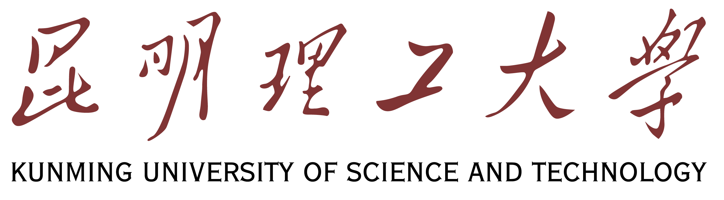

昆明理工大学研究生奖学金申请表
Application Form for KUST Post-graduate Scholarship

照片
Photo
- 申请人情况/ Personal Information:
姓/Family Name:
名/Given Name:
国籍/ Nationality:
护照号码/ Passport No.:
出生日期/Date of Birth:年/ Year 月/ Month 日/ Day
出生地点/ Place of Birth: 国家/Country： 城市/City：
男/Male □ 女/Female □
母语/Native Language： 宗教/Religion：
联系地址/ Contact Address:
电话/Tel: E-mail:

2、个人简历（包括受教育及工作经历）/ Curriculum vitae (including education background and employment record):
学校/工作单位 起止时间 主修专业/从事工作 毕业证书及学位证书
Institution/Employer Years Attended (from/to) Fields of Study/ Work Engaged Certificates/Position

3、语言能力/Language Proficiency
a) 汉语/Chinese: 很好/Excellent □ 好/Good □ 较好/Fair □ 差/Poor □ 不会/None □
HKS考试等级或其他类型汉语考试成绩/Level of HKS test or other certificates which can show your Chinese level:

4、来华学习计划/Proposed Study in China:
a)硕士研究生/Master’s Degree: □ 博士研究生/Doctoral Degree: □
b)申请来华学习专业/Subject of Study in China:
c)申请专业学习时间/Duration of the Major Study:
自/From: 年/Year 月/Month 至/To: 年/Year 月/Moth
d)是否需要补习汉语/Do You Need Elementary Chinese Study prior to the Major Study?
是 /Yes: □ 请填写申请汉语补习时间（不计在专业学习时间）/If ‘Yes’, please in duration the duration of your elementary Chinese study (not included in the length of the major study ).
否 /No: □

5、推荐您申请奖学金的机构或个人/ Specify the Organization or Person Recommending you for this Scholarship:

6、 申请人在华事务联系人或机构/ The Guarantor Charging Your Case in China:
名称/Name: 电话/Tel:

我声明以上所填信息均真实无误。
Ｉhereby declare that all the information for this application are true and correct.

申请人签字/Signature of Applicant: 日期/Date:
(无此签名，申请无效/The application is invalid without the applicants’ signature )

